**Demo of logging the information in the SQL Server**

In SSMS –

Create a new database SSIS_Log_Demo

use master

go

Create Database SSIS_Log_Demo

go

use SSIS_Log_Demo

go

Create Table T1(A int primary Key, B int)

go

At the moment in SSMS there is only one table T1 in the database SSIS_Log_Demo. There is no System table present yet as shown next –

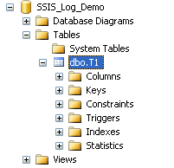

In SSIS –

1. Create a new SSIS Project with the name SSIS_Log_Demo_Package
2. Place one **Execute SQL Task**.
3. Configure this task to the **SSIS_Log_Demo** database.
4. The **SQL Statement** will be --

Insert Into T1 Values(1,2)

Insert Into T1 Values(2,3)

Insert Into T1 Values(1,4)

Insert Into T1 Values(3,5)

*5) Right Click anywhere in the Control Flow Designer Area.

6) Select **Logging** as shown next –

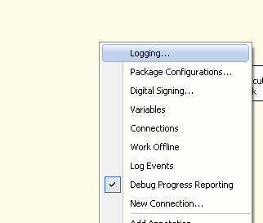

7) In the **Providers and Logs** tab within the **Add a new log** frame select the **Provider type:** as *SSIS log provider for SQL Server* as shown next --

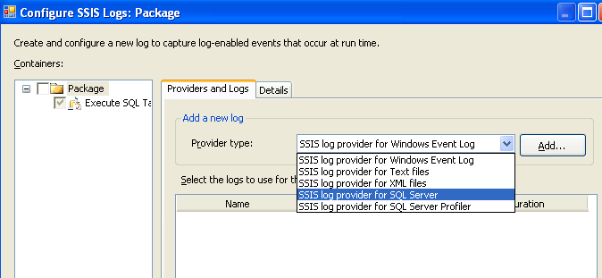

8) Then click on the **Add** button.

9) Select the checkbox near Package node in the left side Containers as shown next –

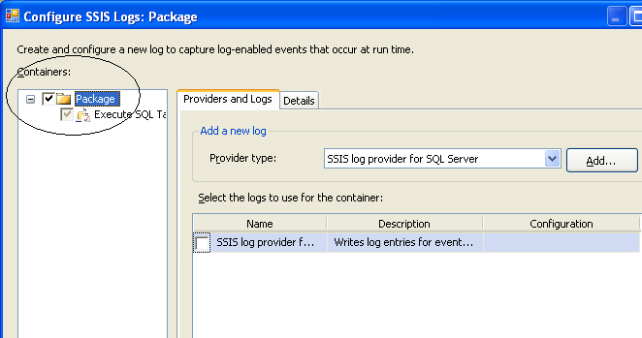

10) In the **Configuration** select the SSIS_Log_Demo database and select the check box before the provider name as shown next –

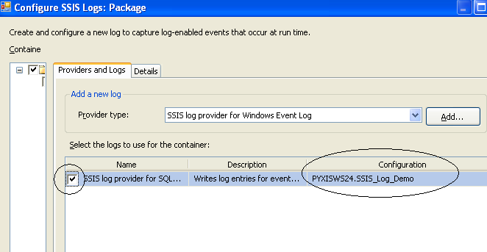

11) Now click on the **Details** tab from the RHS pane as shown next –

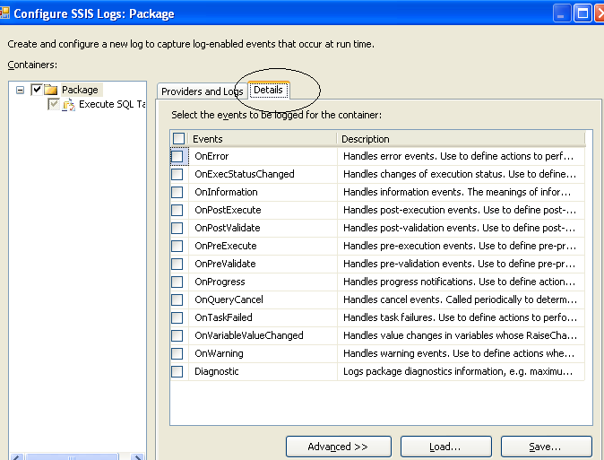

12) Select the events **OnError** and **OnPostExecute** as shown next –

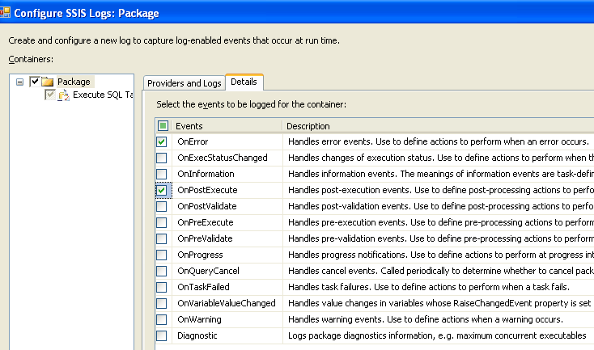

13) Just click on OK button and close this window.

14) Now click on **Start Debugging** button.

Error will come due the duplicate value of primary key and **red** color will come to the **Execute SQL Task.**

In SSMS ---

See the System Tables node from the Table node. A new table gets created whose name is **dbo.sysssislog** as shown next –

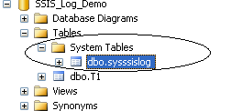

Note 🡪 Log entries are written to the **SysSSISLog** table. This table is created the first time the package is executed with logging enabled.

In SSIS 2005 version the name of this table was *sysdtslog90*.

Query that table –

select * from sysssislog

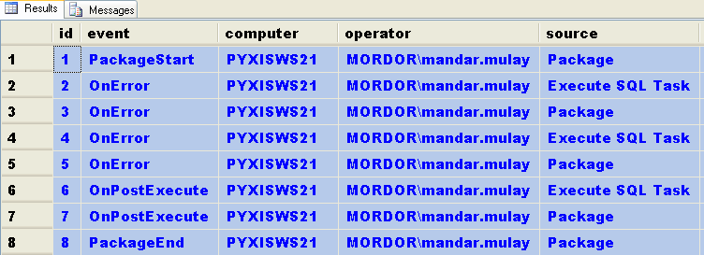

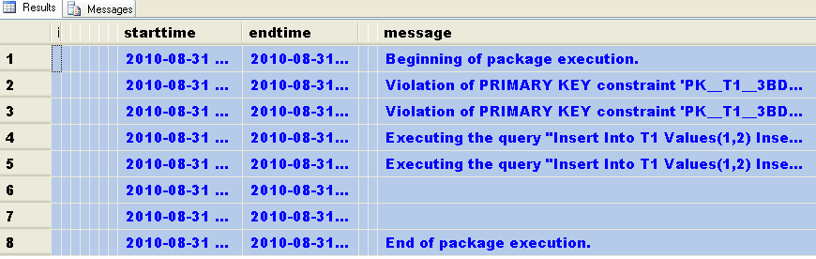

*(Note 🡪 Some of the irrelevant columns are hidden and the output is shown in two images)*

See the number of records in the sysssislog table

select COUNT(1) from sysssislog -- It returns **8**

Now in SSIS change the SQL Statement of the Execute SQL Task control.

The statement should be :

Insert Into T1 Values (100,100) -- There is no error this time

Click on **Start Debugging** button.

The **green** color will come to the Execute SQL Task.

Come back to SSMS –

Again see the number of rows in the sysssislog table

select COUNT(1) from sysssislog -- This time it is **12**

See the records in that table

select * from sysssislog

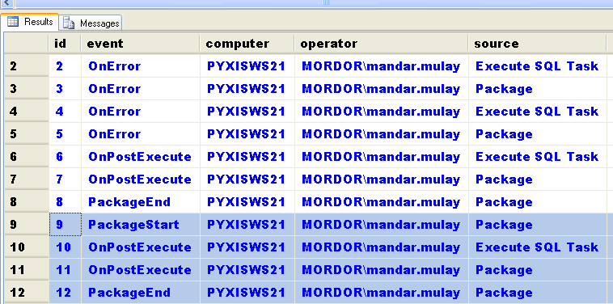

**That means every time the package has run its log will be entered in the sysssislog table implicitly.**

Note 🡪 In future if any new SSIS package is created based on the same database connection of SSIS_log_Demo then the log entries of that package will be appended to the same table sysssislog.